Application -- web app

Language

* ASP.NET C#A

<https://www.youtube.com/watch?v=E7Voso411Vs>

Use Microsoft Visual Studio Community

Mockup- <https://marvelapp.com/>

<https://marvelapp.com/prototype/50c9g36> //our project prototype link

Use Case, class diagram

Is this useful for website testing? <https://www.selenium.dev/>

# Our ideas

* Typical service (book something)
* Birth rate improvement

Main idea

* Women Health App
* *Available local clinic location with specific vaccine/shots/surgery/checkup
  + Link them the website
  + Book appointment to take vaccination for prevention
* Recipes
* *Events (govt/non-profit org) - talks
  + Advertisement (encourage shit/create awareness)
  + Exercise [Top 5 Leading Cancers by Gender](https://data.gov.sg/dataset/top-5-leading-cancers)
* **Something like a group chat/gathering (local user) [social media]
  + Sign up/Sign in?

Data from gov.sg

<https://data.gov.sg/dataset?groups=health&page=3>

<https://data.gov.sg/dataset/top-5-leading-cancers>

<https://www.axa.com.sg/blog/health/top-3-causes-of-death-singapore>

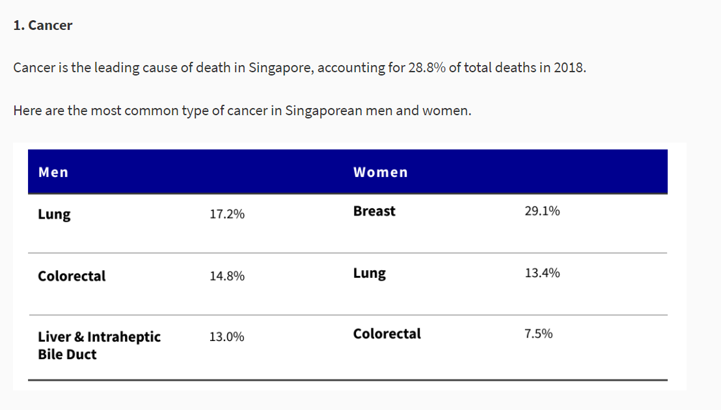Choose lung(women + men) or breast cancer (women)

========================================================================

Proj mission statement – what you intend to accomplish with your project

- Problem: Cancer is the leading cause of death in Singapore. Singaporeans in general are not aware of the causes, and do not go for cancer screening regularly.

- Stakeholders, developers, users

- Outcomes and benefits: More awareness on cancer/ treat it early, etc. Support cancer charities

# Features

* Events (health talks etc.)
  + Simple booking function
  + User get unique code to access their booking details
  + Sharing to other social media platform (optional)
  + Telegram/social media group link in event details (if there is any)
  + Basic create,read, update,delete functions
  + Generating unique code
  + Emailing to user and organization once update/created
  + **Booking clinical appointments need a clinic doctor schedule(dummy data)

* Informative
  + Similar to blog
  + Posts are categorized into different topic (Arranged in different tabs)
  + Health(menopause, fertility etc) / diet (Nutrition) /wellness(self-care, mental health)
  + Below individual post, add in Telegram/social media link (if there is any)
  + Displaying bunch of posts/ user viewing the post
* Map
  + Nearby clinics location based on user provided address (postal code etc)
  + Detail of clinic (phone number, email, address)
  + API usage required
  + Further filter the clinics by availability of the service (dummy data)

Use Cases:

1. View articles(User)
2. View events(User)
3. View registered event(User)
4. Sign up for events(User)
5. Update event registration(User)
6. Withdraw from event(User)
7. View clinics(user)
8. View available screenings(User)
9. Book appointment(User)
10. Update appointment(User)
11. Delete Appointment(User)
12. Filter clinics to nearby(System)
13. Filter clinics by availability(System)
14. Generate unique code(System)
15. Email event details and code to user(System)
16. Email details to organizer(System)

Use Case Description: ***I created another google doc for it cuz it too long to put it here, else everything very messy. Just follow the link below.***

<https://docs.google.com/document/d/1II5Kj90h99MSuFcrcXV3Aj63Jt4Xq15kZq0IGH-XUI4/edit?usp=sharing>

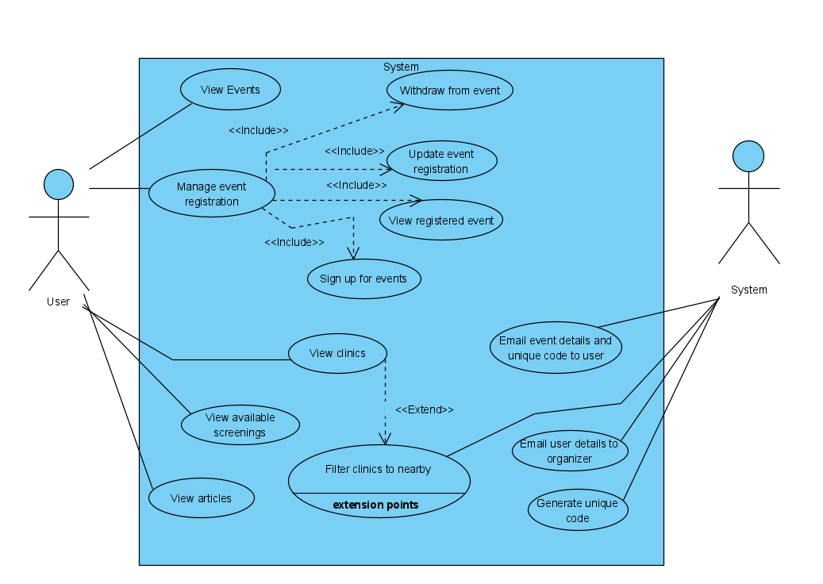

# Overview of the lab tasks

## Lab #1

1. Requirements elicitation:

Determine the target users of your application. Elicit functional and non-functional requirements of the application.

Document the requirements in appropriate technical format. The requirements should

clearly state who performs what system functionality, taking what input and producing

what output.

Atomise the requirements such that they are verifiable and traceable

→ Documentation of functional and non-functional requirements

1. Use case model

* Use case diagram (using UML/ ppt)
* Use case description

→ Initial use case model: diagram + descriptions

1. UI mockup -- can be ppt, hand drawn, etc

* Follow HCI principles

### Deliverables

• Documentation of functional and non-functional requirements -- Daniel

• Data dictionary -- Daniel

• Initial Use Case Model, consisting of Use Case diagram and Use Case descriptions- Joyce

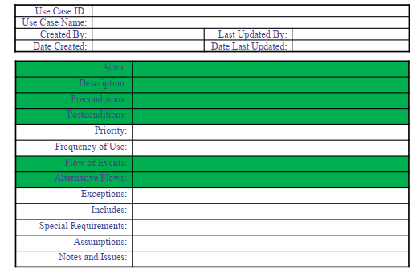

• UI Mockups -- Ray & Guan Wei

Problem statement and background research - Kee yang

Please submit the deliverables to your SVN repository (under the folder “lab1”) before

Lab#2 starts. Your Lab Supervisor will want to see and discuss the deliverables with you

during Lab #2.

## Lab #2

Refine Use Case Model

Build the Conceptual Model

* identify the initial entity, boundary and control objects and their attributes.

Build the Dynamic Model

* model the interaction between the boundary, control and entity classes from the conceptual model, to enact the flow of events in the Use Case Description. Specify the messages and parameters passed between classes in a Sequence Diagram. Use the stereotyped classes to guide the direction and sequence of messages exchanged.
* Model the system behavior in a State Machine of UIs based on the UI mockups

### Deliverables

Complete Use Case diagram

Use Case descriptions

Class diagram of entity classes

Key boundary classes and control classes

Sequence diagrams of some use cases

Initial Dialog map

## Lab #3

Once your design model becomes stable, you can start mapping your design model onto code.

That is, start implementing your system

Transform analysis model into design model

* make a draft design class model
* Add a start-up class (which performs system initialization)
* Add control classes and distribute the logic and coordination responsibilities amongst them
* Add container classes to hold collection of objects, e.g. List
* Apply design patterns where appropriate

Address key design issues

* Identifying and storing persistent data
* Providing access control

Implement your design in code

* generate the skeleton code
* Document the classes and the key public methods to convey design intent and usage using Javadoc or similar techniques for other programming languages

### Deliverables

Complete Use Case model

Design Model

o Class diagram

o Sequence diagrams

o Dialog map

System architecture

application skeleton

## Lab #4

Implement your application

* Generate skeleton code from design model
* Implement attributes and behaviour
* Organise code into folders/ package
* Use SVN repo to collaborate

Design test cases using black box and white box testing techniques

* Equivalence classes and boundary testing
* basis path testing techniques to test two methods that implement complex application logic
* Minimize the number of test cases through the careful selection of test input using proper black box and white box testing techniques learnt in the course
* Manual or auto testing

Plan for live demo

* Craft the demo script and sequence to present the product well
* Demonstrate the various usage scenarios by the different end-users
* highlight innovative solutions in the application, as well as, elements of good software engineering practices and system design.
* prepare a five-minute screen video of the application. You can provide voice-over to explain the functionality

Prepare SDLC work products for delivery

* Complete and sufficient documentation
* Document the traceability from requirements to design, then to implementation, then to test cases

### DELIVERABLES

Working application prototype

Source code

Test Cases and Testing Results

Demo script

## Lab #5

Demo working product

Submit lab deliverables to SVN

Submit other documentation. (diagrams, state machines, meeting minutes, etc)

* Can compile into a pdf/ docs. Images

Submit demo video of the working product

Submit peer review

# 1.Requirement elicitation

## Documentation of functional and non-functional requirements

Functional

Our website will firstly be providing information about health.

Such as a healthy recipe, lifestyle.

Our site will also be providing interactive service to our users.

Such as providing nearby clinic location based on user provided location for health checkup.

Our website will provide connections to local social groups,such as telegram groups, to help create a community.

Finally, our site will also be providing information and link to relevant events.Such as government organised event, health talks , or user organised outing(exercise)

Non-functional

## Data dictionary

## Initial Use Case Model, consisting of Use Case diagram and Use Case descriptions

## UI Mockups